Donald E Shannon, CFCM, CPCM, NCMA Fellow
dba The Contract Coach | Albuquerque, NM

Interim Progress Report and Recommendations Concerning Affordable Cybersecurity for Very Small Businesses.
A Cyberhygiene Project Update
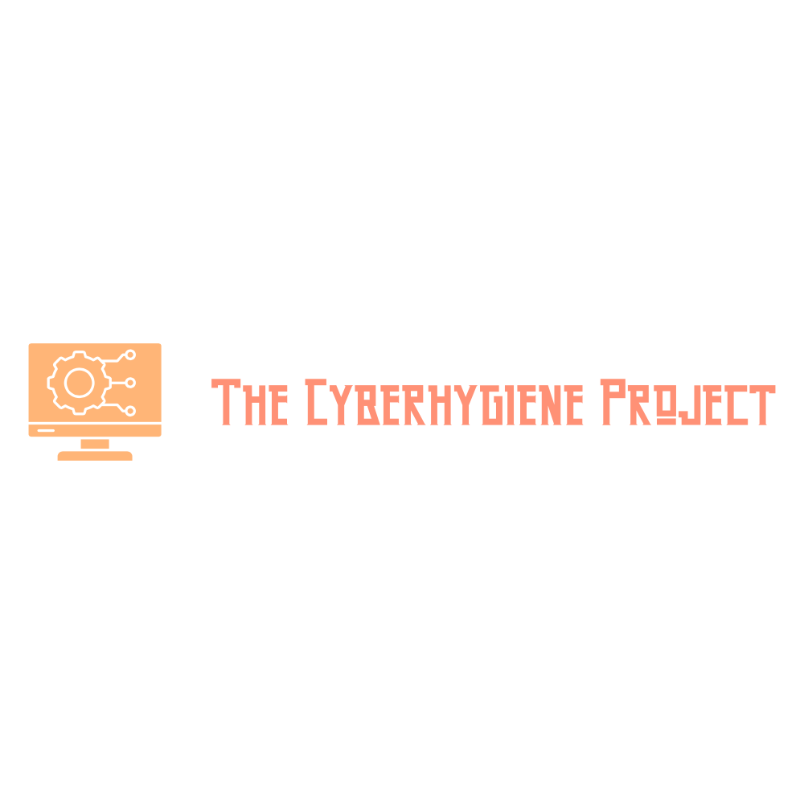

Table of Contents
Executive Summary 2
Research Update 2
The Need to Automate the Documentation Process 2
Conducting Thorough Needs Assessments 3
Cyber Hygiene Level 4
Cyber Hygiene + Level 5
Basic CUI Compliant (Level 2) 6
Detailed Cybersecurity Documentation Approach Described 8
Network inventory 8
Endpoint management and hardening 10
Reporting Tools 13
Conclusions and Recommendations. 14
1. Begin Work on a “TurboTax” Style Document Engine 14
2. Create a Level 1 Compliance Kit Immediately 15
Solopreneurs 15
Micro Offices 15
3. Create a “NAPEX Store” for Virtual Secure Workspaces and SAAS 16
4. Establish a network of Managed Service Providers (MSP) 16
Appendix 1 - Equipment and SAAS List with Pricing 17
Level 1 Solopreneur Laptop Configuration 17
Level 1 Workgroup or Nano-Office 18
Recommended Additional Software 18
Appendix 2 – Sample Compliance Checklist for Level 1 0
Appendix 3 - Windows 11 or Linux? 0
Dissatisfaction with Windows 1
Improved User Experience 1
Developer and Professional Adoption 1
Challenges and Limitations 1
Key Linux (Ubuntu Pro) Security Features vs. Windows 11 1
Appendix 4 - DCAA Chart of Accounts for GnuCash 6
CSV Content 6

Interim Progress Report and Recommendations Concerning Affordable Cybersecurity for Very Small Businesses.

by Donald E. Shannon, CFCM, CPCM, PMP, Fellow

Executive Summary
Work continues on the Cyberhygiene project with this as an update for the two months since the May 7th NAPEX conference. Much of the research has been directed towards investigating new tools related to Ubuntu Linux driven by the end of life coming for Windows 10 operating system and the many criticisms of the Windows 11 replacement. Installation of a dedicated WAN connection for the project has opened the door to exploring security options at the network gateway using the NetGear 2100 router.
Much attention has also been given to the virtual secure environment approach for securing a CUI environment that is segregated from the other network devices or activities. Two approaches have been explored with a recent commercial offering from ATX Defense being a likely recommendation.
Finally, the need for documentation and automation in the cybersecurity compliance activity has taken a prominent role with a recommendation for a user-friendly ‘expert system’ approach like the “TurboTax” style product envisioned.

Research Update

The Need to Automate the Documentation Process
Today, very small businesses, i.e., ‘mom and pops’ with only a handful of people find themselves in the cybersecurity equivalent of April 14th standing in a long line outside H&R Block with a shoebox filled with receipts and slips of paper. We have slipped through time back to the 1980’s where there were no personal computers and no TurboTax® to help us and we are left to our own devices and paying someone else to do our homework.
Like then we understand the requirement to comply with the law and the need to do so, but the very small businesses in the government contracting space are between a rock and the proverbial hard place. It’s not that we don’t have calculators, tax schedules, and a box of receipts – rather it’s a question of dealing with a complex tax code with lots of twists and turns and bureaucratic gobbledygook. We need a sherpa!
The comparison to income tax and TurboTax is intentional. For many of us, products like Quicken®, QuickBooks®, and TurboTax® were significant time and money saving developments. In the small business community, it made it easier and faster to comply with quarterly tax payments, annual tax returns, and recording day-to-day transactions. We gained the ability to be compliant without being hostage to an army of CPAs and ‘financial advisors’. Ultimately it also created a powerhouse software and services company and transformed the way many of us do business. Using structured questions and workflows the software gathered the necessary data; formatted it; confirmed it with online data sources from employers, banks, and government databases; and then created the necessary documentation to complete a compliant return.
Precisely what we need for cybersecurity at the very small business level. Cybersecurity could use a big dose of the same “TurboTax” medicine – complete with audit support should the need arise.

Conducting Thorough Needs Assessments
Very small businesses in the government contracting environment (GovCon VSBs) cover a broad spectrum of sizes, products, and segments. The principle segmentation begins with the customer – usually boing down to “defense” comprised of the Department of Defense, Homeland Security, Intel agencies, and NASA, or “Commercial” comprising the remaining government departments such as Health and Human Services, Interior, Agriculture, etc. The primary distinction between the segments from a cybersecurity perspective is the volume and sensitivity of Federal Contract Information (FCI) in the contractor’s possession.
The statement by DSCA is very straightforward with respect to FCI vs. the better known Controlled Unclassified Information (CUI): “All CUI in possession of a Government contractor is FCI, but not all FCI is CUI.” The take-away is FCI is not releasable to the public (by the contractor) but is afforded a lesser level of protection (Level 1) as opposed to CUI which has a higher standard of protection (Level 2 or Level 3) depending on sensitivity.
Therefore, when assessing cybersecurity compliance need for a client small business the first step is identifying the quantity of FCI and if any of that information will be CUI. Making this assessment has been tricky as government contracting officials are often non-committal concerning what level of information will be created, handled, or provided in a specific contract. Consequently, the GovCon VSB is in an uncertain position as to what cybersecurity measures will be needed – and since these measures have an associated cost the uncertainty may result in indecision or inaction.
The requirements of FAR 52.204-21 which are inserted into all contracts by both the Defense and Commercial sectors of GovCon establish a baseline requirement at Level 1 for FCI and thus the default recommendation is for all GovCon VSB’s to immediately attain Level 1 compliance.
The necessity for Level 2 or Level 3 compliance is driven in large part by the agency and their disclosure of CUI requirements in a contract or solicitation. FAR Case 2017-016 Controlled Unclassified Information is intended to address the uncertainty as follows:
“SF XXX, Controlled Unclassified Information (CUI) Requirements, was developed to promote consistency, assist Federal agencies and contractors in the identification of CUI in agency requirements, and uniformly define all associated handling requirements in accordance with 32 CFR part 2002. The SF XXX will be included in solicitations and contracts that may result in the handling of CUI that will ultimately become performance requirements during contract performance.”
Unfortunately, FAR Case 2017-016 is in bureaucratic limbo and is likely to be affected by the FAR rewrite process and may take months or even years to be finalized and implemented. In the interim GovCon VSBs face the Delima of spending money for a higher security level than needed or not being eligible for specific upcoming contracts which require attainment of the specified cybersecurity level as a contract award criteria.
A portion of this needs assessment then is not only determining the appropriate level of security but also the scope (what’s covered) and the method by which the needed level is attained.

Cyber Hygiene Level
The most reasonable level of cybersecurity compliance for a GovCon VSB is Level 1 for the entire business environment – office, work from home, etc. – for all company employees and assets. Attainment is predicated on the 15 basic safeguarding requirements specified in FAR 52.204-21 because – as shown in the below table – it is the most likely scenario for businesses.

Table 1 Estimated number of CMMC Assessments Required
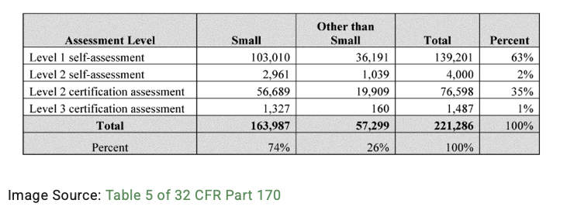
Considering that some 70+ percent of the 103,000 small businesses in the DoD GovCon are fewer than 15 people, the need for a low-cost Level 1 solution (also known as ‘cyber hygiene’) and its importance in the cybersecurity implementation sector is apparent. Cyber hygiene is also flexible in that it can easily encompass a sole proprietor with a home office up to a small office environment with 15 employees with essentially one flexible solution.

Sole Proprietor Solution
A significant portion of the DoD GovCon VSBs sector is comprised of a sole proprietor or a ‘one-man-band’ doing business as a consultant, researcher, or other specialized role. Compliance for this group could be as simple as basic policy documentation and a hardened laptop (or legacy device), and a secure email solution such as Proton or PreVeil. Such a laptop could be configured by a third party as a turn-key Level 1 compliant device at an affordable cost. Included in the configuration would be a software load including BitDefender Gravity Zone and either Senteon or Ubuntu Pro depending on OS to ensure device configuration and policies are established, monitored, and enforced. Documentation requirements are relatively simple with many requirements be not applicable due to the lack of a defined network. See Appendix

Small Workgroup Solution
For workgroups comprised of two or more individuals the solution is similar (i.e., 2 or more such devices or equivalent configuration of legacy devices) but adds the additional issue of maintaining control over who has access to shared devices and data within the group. The traditional manner of addressing this is to establish a domain managed by a domain controller. The controller can be a physical device such as the Synology Disk Station discussed in earlier reports – or could be a virtual device like a cloud service from MS365 or JumpCloud. At this level a solution like the free tier of C2 Identity would provide identity management while Bit Defender Gravity Zone and or Senteon. Documentation requirements for this solution are somewhat more detailed as the network is now a component requiring access controls, identity verification, encryption, etc. to be documented. Using a cloud service such as JumpCloud or MS365 Enterprise would add a recurring cost but would provide a robust and well documented compliance audit trail. The on-premises solution using the Synology DS is likely to have lower total cost of ownership if evaluated on a multi-year basis.

Cyber Hygiene + Level
When the CMMC levels were changed from the original five to the present three we lost what I consider to be a ‘sweet spot’ for many businesses. That is a transitional level between the minimal requirements (15 controls) in Level 1 and the full 110 controls in the now Level 2. Plus (i.e., Cyber Hygiene + ) is a concept that encourages businesses to add common sense and often available at little or no added charge functionality or features to their Level 1 compliance effort. For example, BitDefender Gravity Zone provides not just malware protection and policy enforcement it also can provide (at minimal extra cost) automated activation of BitLocker drive encryption (with secure storage of recovery keys) and automated patch management.
Senteon and/or Ubuntu Pro offer cloud-based configuration management and remediation capabilities to harden devices and monitor drift. Setting the configuration to a robust level is no more expensive or complex than selecting a less secure configuration baseline and should be encouraged.
The intent is that many of the NIST SP 800-171 requirements can be met at the Plus level thus speeding and easing the transition to a Level 2 should (or when) the need arises.

Basic CUI Compliant (Level 2)
Adding CUI compliance entails 1.) meeting the NIST SP 800-171 requirements and 2.) conducting an assessment to assure compliance. The contracting agency will specify if a self-assessment suffices or if an independent third-party assessment is required. I have identified at least two compliance scenarios applicable to GovCon VSBs that could be used:

Secure Enclave Approach
The easiest means for an entity operating at a Cyber Hygiene or Plus level is to establish a secure enclave with only a small fraction of their office dedicated to processing CUI. The enclave can be physical (a room with segregated network connectivity) or virtual (cloud-based or run on a dedicated platform).
Several virtual solutions present themselves and I have looked briefly at the following:
- KASM. KASM can be installed on premises as a virtual machine (i.e., Ubuntu VM hosted on a physical server) or as a Docker appliance. The Docker appliance is a preferred installation as KASM operates in total isolation from the host resources and by default destroys session information. KASM is a desktop environment that – in turn – supports running various applications such as email clients, browsers, or office apps capable of accessing, creating, storing or modifying CUI.
- CMMC Space (ATX Defense) “Level 2 is a complete CMMC Level 2 solution with all required documentation (including a System Security Plan), Google Workspace licenses with CMMC configuration, and virtual environment access. CMMC Space supports ITAR data with an additional license (no migration required!).” The following is from their web page:
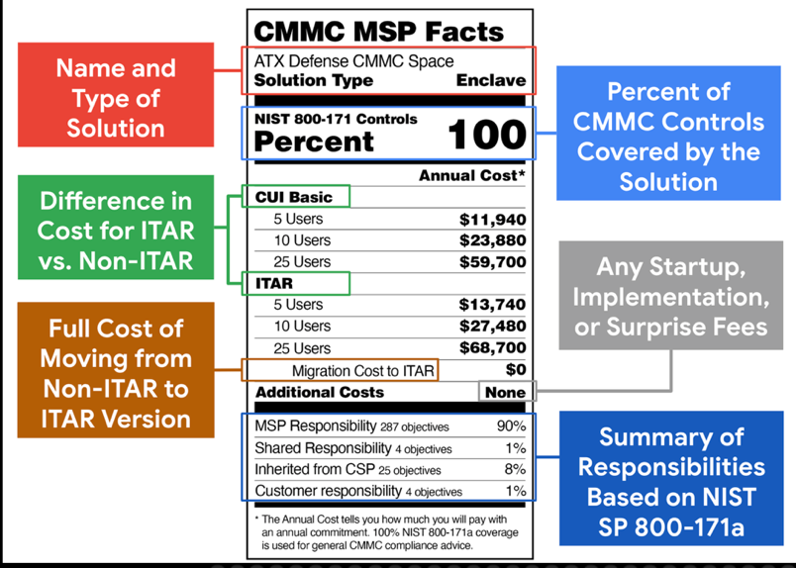

Secure Premises Approach
The secure premises approach is the default answer for many businesses that want to avoid managing network segmentation or cloud-based solutions. This could be an end-point for many GovCon businesses as the entire facility is included in the scope of the Level 2 assessment and one set of rules cover all equipment, operations, and policies.
Moving from a Cyber Hygiene or Plus office to a Level 2 office is not trivial but starting from a somewhat mature environment make the process manageable. Many of the security objectives will have already been addresses – either partially or completely in the previous security efforts – especially if a Level 2 secure enclave has been established. Leveraging those preceding efforts will however disclose some areas where rework or alternate solutions must be introduced. Here’s a summary:
- Domain Server. If an on-premises domain controller (DC) such as the Synology DS has been used it may not meet the Level 2 requirements. This can be solved by demoting it and using a virtual cloud-based domain server approach such as JumpCloud or MS Azure. The main issues with the Synology approach is its lack of FIPS 140 encryption support and no specific DISA STIG published for hardening it to NIST SP 800-171 requirements. If an on-premises DC a Linux server running the appropriate services such as Samba, LDAP, etc. could be assigned DC duties replacing or supplementing the Synology device depending on preferences.
I have desigbed and priced a 1u rack mount server that would do the job easily for about $2,200 … roughly the same as the Synology albeit focused on compute duties as opposed to file server duties.
- Documentation. The level of detail and volume of documentation increases dramatically from Level 1 to Level 2 with many new policy documents and procedural checklists required.
- Network Monitoring and Reporting. Unless it has been included in the Level 1 or Plus implementation a much more detailed network monitoring solution will be needed to meet Level 2 requirements. Fortunately the NetGate router specified in the basic hardware requirements will run Suricata which is a no-cost

Detailed Cybersecurity Documentation Approach Described
Nowhere in the realm of cybersecurity – especially at the low end ‘mom and pop’ level does the TurboTax® analogy fit better than with the regulatory driven areas of documentation and compliance. Cybersecurity as envisioned in various security frameworks (why must we use that term anyway?) is largely an exercise in establishing mature processes to replace the often ad hoc methods used by less sophisticated companies. The same can be said of quality management, accounting, financial control, risk management, earned value, etc. All are efforts to reduce and manage some business risk by creating systems of controls that thwart risky or outright malicious actions.
The preferred tool of these maturity systems is the policy manual and associated procedures and checklists. The intent is to identify proper behaviors and plan for correcting deviations or disruptions. The intended effect is to eliminate or mitigate known risks through proactive means.
The structured query – response – documentation approach of tax software is well aligned with quizzing the business owner, capturing their response, and then producing documentation like policy manuals, checklists, procedures, implementation guides. This process will likely be integrated with the network exploration and documentation step described in the next section so as to tailor the results according to the actual characteristics of the business including data import from SAM.gov and automated submittal of data to SPRS.

Network inventory
Next up is a need to document the network assets that comprise the ‘scope’ of the cyber secure network. What is needed is a tool that scans a business’s IT (and OT if present) creating an inventory of assets, software, and possible security vulnerabilities into a fully documented network diagram and compliance report. There are some tools available that can do significant parts of this task. Some can even correct or reconfigure the applicable settings to ‘make things right’ from the NIST 800-171 point of view.

Figure 1 CyberLab Network and Boundaries (Scope)

While the above hand drawn network diagram is very helpful, automated products such as Domotz provide network topology diagrams at the click of a mouse.
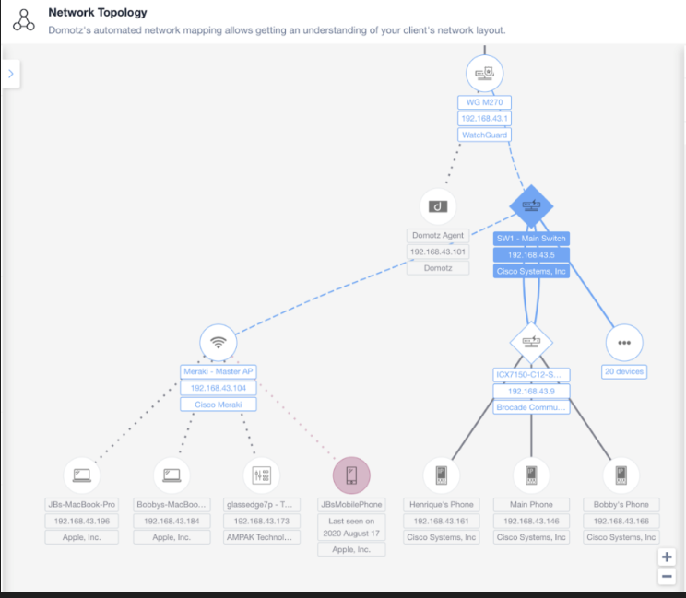
Figure 2 Sample Network Diagram from Domotz
Going further however, such a product should also provide a database of all network assets (including details of installed software products) making management less complex and be scheduled to create a new snapshot periodically to account for changes.

Endpoint management and hardening
Next issue – automated endpoint protection and hardening. Networks contain computers, printers, tablets, telephones, switches, relays, and any number of other devices. Each of these ‘endpoints’ is vulnerable to attack by malware or intrusion by data snoops looking to steal company intellectual property or data. The defense against such tactics is to close and lock as many of the ‘doors’ or access points to your network and devices as possible. Are there tools to automate this process? Absolutely. Here are a few:
Senteon. Senteon’s software works on windows devices and will automatically scan devices (workstations or servers) running windows to identify variances in several hundred settings from baselines published by cybersecurity experts. The enforcement is accomplished using a template approach with the client selecting the appropriate security framework (CIS, NIST, ISO, etc.) and then tailoring it (if need be) to fit a particular use case.
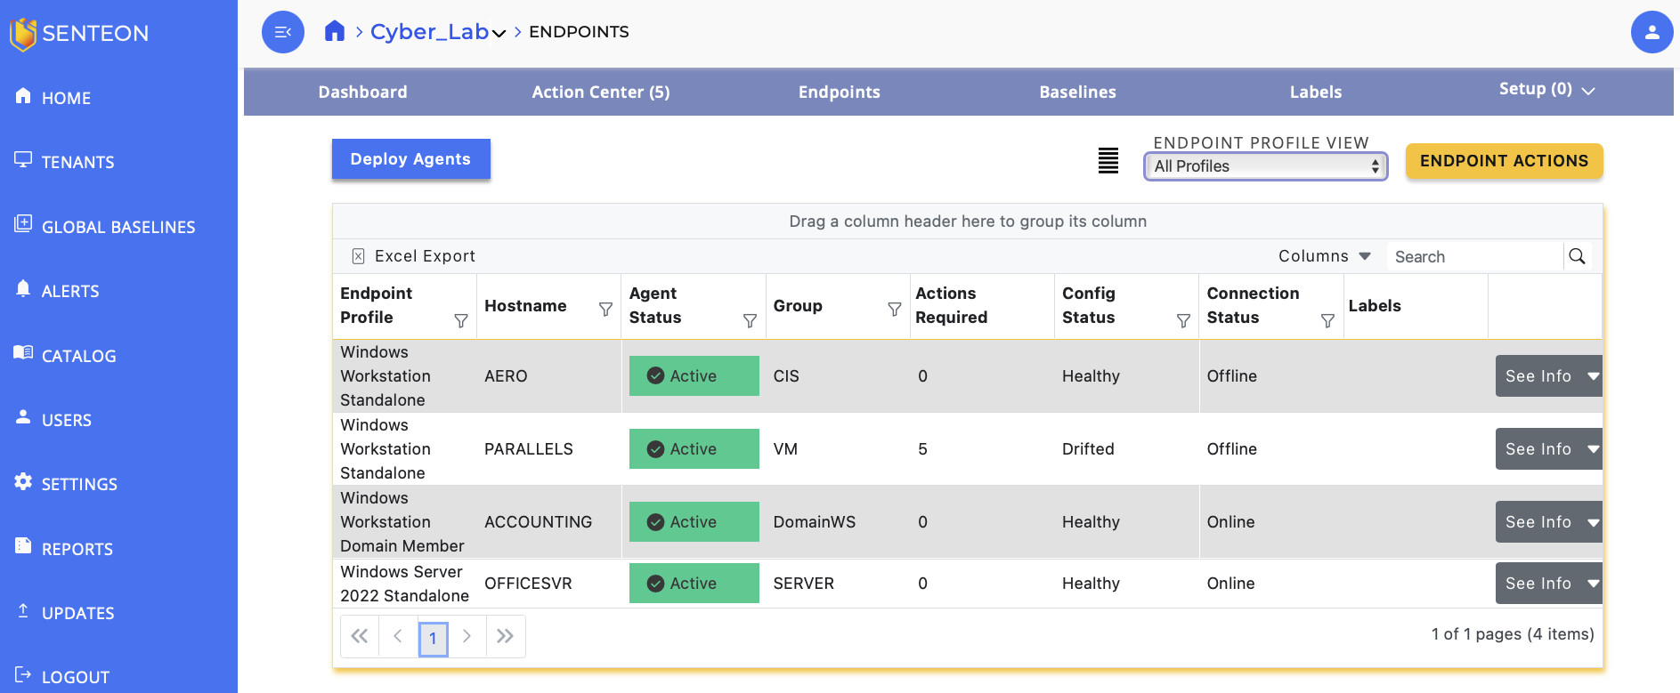
Figure 3 Senteon Compliance Dashboard
Once the template is applied to an endpoint Senteon’s cloud service monitors these settings and alerts the owner to ‘drift’, even offering to automatically correct the deviation. Down side? Only works on Windows and Google Chrome. No templates have been developed for other operating systems or software, although Senteon is a new company and just getting started.
BitDefender Gravity Zone -endpoint protection and management. Gravity Zone provides BitDefender’s highly respected anti-malware product enhanced with numerous additional services and features including remotely enabling drive encryption, automatically deploying software patching, deploying and enforcing security policies, replacing the Microsoft Defender firewall with the Bitdefender firewall, status monitoring, intrusion detection, and more.

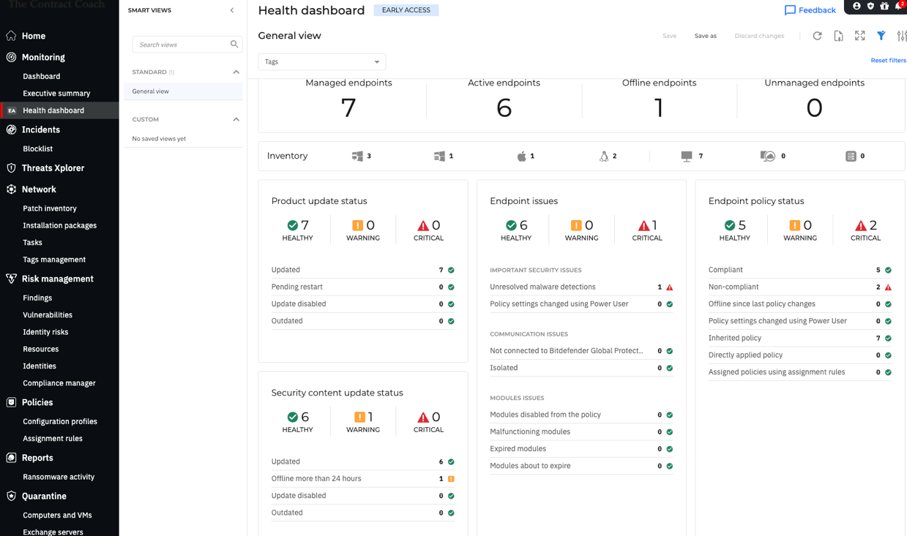
Figure 4 BitDefender GravityZone Dashboard

GravityZone is comprehensive, highly automated, and effective. It’s compliance manager (optional feature) provides detailed compliance information aligned by security framework.

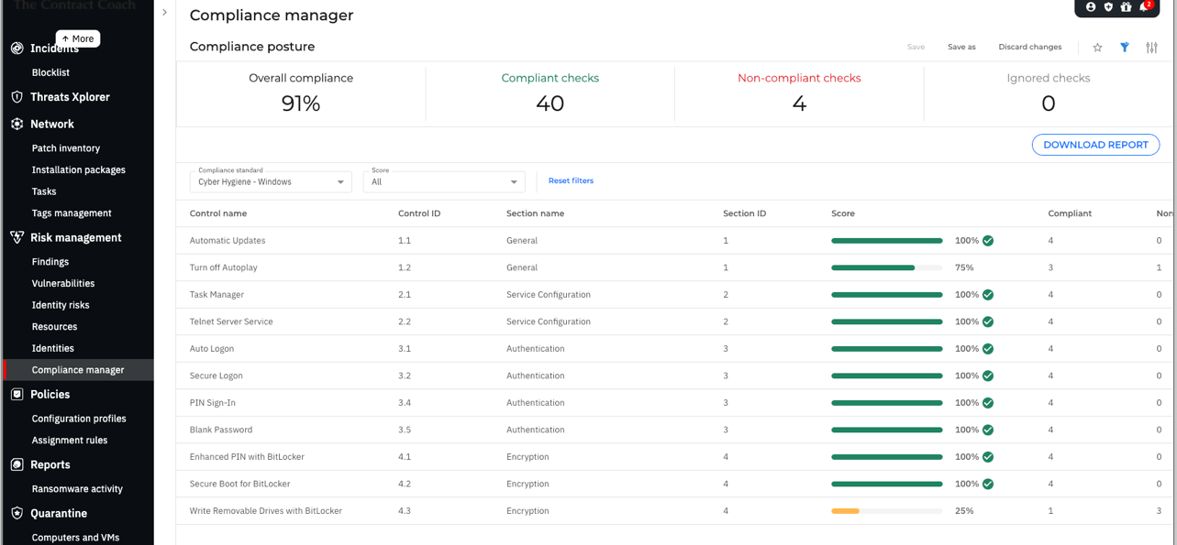
Figure 5 BitDefender Compliance Status for NIST/CIS Requirements

It is highly automated, effective and provides cross platform support – albeit it is primarily focused on Windows and Mac with only limited support for Linux.
Ubuntu Pro. Ubuntu offers the Ubuntu Security Guide (USG) – a step up from the basic distribution and free for up to 5 licenses. The USG adds a number of security enhancements and the tools (albeit from the command line interface) to apply a number of security baseline templates (similar to Senteon) to a Ubuntu installation.

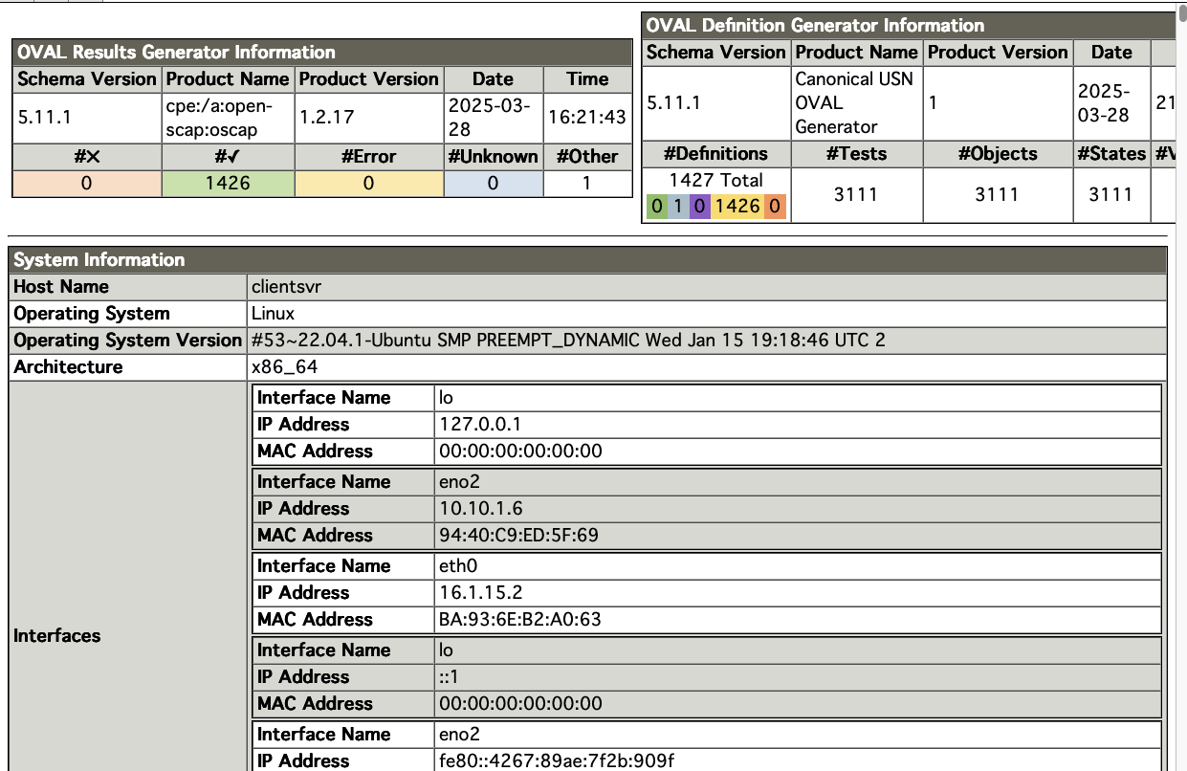
Figure 6 Extract from Ubuntu Pro's Security Guide Compliance Audit
Adding compliance with DISA STIGs on a Ubuntu platform is trivial using the USG capabilities. Here is how it’s done from terminal with just three commands:
sudo pro enable usg
sudo usg audit --profile disa_stig # Audit system against Ubuntu 22.04 STIG
sudo usg fix --profile disa_stig # Apply fixes to achieve compliance
Reports are run using tools from the Open Vulnerability and Assessment Language (OVAL®) toolkit from MITRE (sponsored by the US DHS) and are highly correlated to other U.S. Government cybersecurity tools like STIG and SCAP. Consequently, the product yields a report that is easily compared against such standards to assess compliance. The Results generator tells it all – the system is fully compliant with the NIST 800-171 Level 2 STIG with 1426 results in the Green and no errors. Impressive.
The above are the tools I used and am comfortable with. There are others like HardeningKitty for Windows that I have used in the past but am reluctant to fully endorse because the definitions are not updated frequently to keep pace with evolving threats. There are other tools available that I have not evaluated because of cost or technical complexity.

Reporting Tools
Compliance with the cybersecurity standards involves monitoring of the network environment and end points to identify possible security breaches and to ensure that endpoints have not drifted from their previously hardened state. Tools for this purpose are built-in to products like Senteon and BitDefender Gravity Zone and provide data on device compliance and limited information concerning the network.

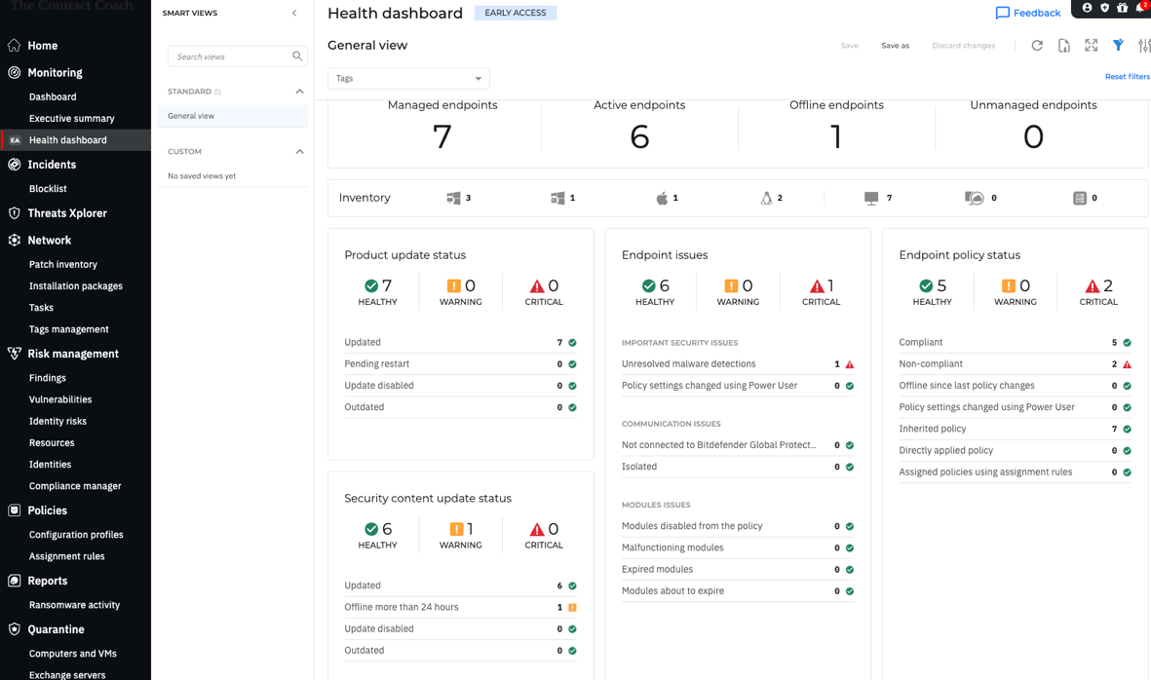
Figure 7 Gravity Zone Main Dashboard Showing enrolled assets and status

Taken in concert with the other reports such as compliance and vulnerabilities this provides the system owner or monitor with an assurance of continued compliance and risk mitigation – including network intrusion threats.
Intrusion detection and reporting are accomplished by the firewall product at the network gateway. The NetGear hardware and pfSense software provides reports such as the below:
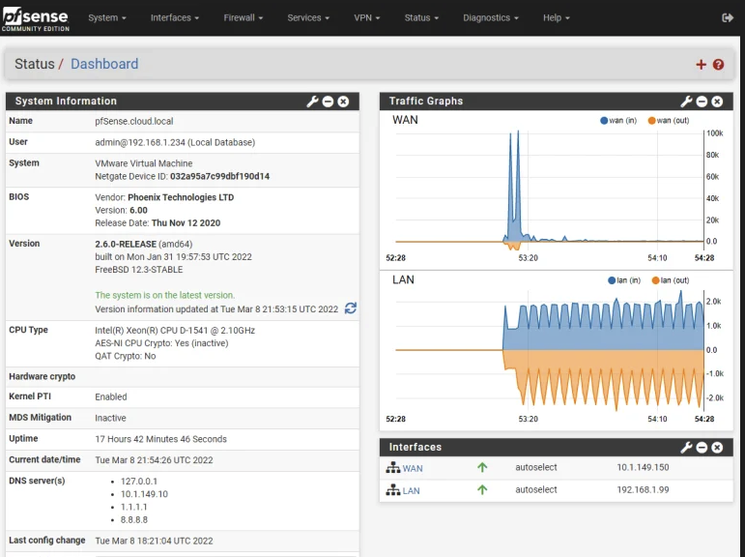
Figure 8 pfSense Dashboard and Activity Report
Additionally, Intrusion detection is monitored by Suricata which “implements a complete signature language to match on known threats, policy violations and malicious behavior. Suricata will also detect many anomalies in the traffic it inspects. Suricata is capable of using the specialized Emerging Threats Suricata ruleset and the VRT ruleset.
Data and logs collected by Suricata are then collected and stored by Graylog. “Built as an open-source project, Graylog Open is a self-managed, SSPL-licensed centralized log management solution designed for log data aggregation, analysis, and management. Tens of thousands of organizations and home lab enthusiasts worldwide actively deploy and use Graylog Open to get answers from their log data.” Graylog’s analysis engine scans logs for threats and reports then automatically.

Conclusions and Recommendations.

Begin Work on a “TurboTax” Style Document Engine
As noted above the documentation issue is a major stumbling block for cybersecurity compliance. The availability of the tool described would dramatically improve compliance. My suggestion is to use the relationship between APEX Accelerators and academia to encourage development as a student AI project using a local AI trained on the NIST requirements, the CH Project architecture and software stack, and the general templates available from Carnegie – Mellon, CISA, SANS Institute, PurpleSec, or CIS.
Other developers to consider are the OpenSCAP community (https://openscap.org) which already provide free and open source tools to scan for compliance thus making them a potential go-to for developing or collaborating on the “TurboTax” documentation tool. Similar tools are currently available from Drata (https://drata.com) albeit as a paid service and tailored for SOC2 etc. vs. NIST

Create a Level 1 Compliance Kit Immediately

Solopreneurs
Creating a Level 1 compliant solution for entrepreneurs, consultants and other one person organizations is easily doable consisting of a laptop, on-line training, documentation templates, and subscriptions to various services or products. Specifications and cost are provided in the attachments to this paper. This solution is well suited for self-administration. It would benefit from the automated documentation approach discussed above which could also be expanded to provide virtual managed services support.

Micro Offices
Level 1 compliance for Micro offices (2 – 15 people) can start with two or more of the Solopreneur laptops (or legacy systems appropriately hardened) and the recommended addition of the existing cyber hygiene (CH) collection of products and services. To meet the requirements for Level 1 the following actions must be completed:
- Documentation must be created to cover the minimum required policies (see attached Sample)
- An Active Directory or LDAP solution must be implemented to meet Access Control requirements 3.1.1 and 3.1.2
- Network monitoring (internal and external) must be initiated; logs collected and stored; and alerting mechanisms such as Intrusion Detection and Response must be used.
- Physical Access Controls must be implemented
- Strong anti-malware protection installed for all information resources.
Meeting these requirements is possible via a pre-configured CH deployment consisting of the hardware and software products identified in the attachments augmented by on-site technical support during start-up.
The level of complexity for this implementation is moderate. While some of the VSBs using this solution will be able to self-administer the solution – especially if some of the cloud-based products used are provided with a help desk option, additional support via a local MSP is recommended.
The trade-offs will be in the selection of commercial paid services vs free – largely on-premises solutions and the scale of the deployment.

Create a “NAPEX Store” for Virtual Secure Workspaces and SAAS
Solopreneurs or very small offices needing a level 2 option are likely best served by a virtual secure environment such as that provided by ATX Defense. The major problem with this approach is the marketing model of these companies have minimum size requirements such that even if only one person needs the service the price starts at five seats minimum.
One approach around this might be to form a consortium, Joint Venture, or similar structure that could aggregate users. This is an area where economic development agencies such as NAPEX could assist by establishing or facilitating such services through as a group buy approach whereby the accelerator holds the license and collects a fee from members to cover costs.
Group purchases through BitDefender, ATX, Senteon, JumpCloud and others or reseller agreements that would support discount pricing for the smallest of businesses would also facilitate adoption by softening the price impacts.
For example both Dell and HP offer laptops with Linux pre-installed. Becoming a value added retailer for these would allow pre-loading and configuring the laptops to be not only hardened but set-up with all the needed services and utilities to make the transition relatively painless.
One activity that NAPEX could take the lead on is researching potential discounts for APEX clients with hardware or software providers.

Establish a network of Managed Service Providers (MSP)
The availability of a MSP for tech support will be a key enabler to the project success. The most easily accessed population would be from students at sponsoring colleges and potentially APEX clients.
NAPEX could facilitate negotiated rates for APEX clients and could assist with enrolling the contracted MSPs as resellers for the various services included in the CH package and/or building and pre-loading systems for local clients.
This is a topic worth future discussion and development at both a national and state level. The opportunities to leverage existing jobs or workforce development programs at the state level is especially worthwhile.

Appendix 1 - Equipment and SAAS List with Pricing

Level 1 Solopreneur Laptop Configuration
Table 2 Laptop Hardware Configuration Table
Item | Description | Estimated Cost
Laptop (Linux) | Pre-configured laptop system for solopreneurs or VSB Office
 | Hardware (depends on intended use and software selected). Suggest i5 processor, 15-inch screen, 16 Gb RAM Standard, 32 Gb Optional) 512Gb – 2 Tb SSD Recommend HP or Dell – do not recommend Lenovo | $450 - $1100
 | Ubuntu Pro | Free
 | OnlyOffice Desktop | Free
 | BitDefender Gravity Zone Business (End Point Management and anti-malware) | $50.00 (annually)
Laptop (Windows) | Pre-configured Laptop system for solopreneurs or VSB Office. Recommend HP or Dell – do not recommend Lenovo
 | Hardware (depends on intended use and software selected). Suggest i5 processor, 15-inch screen, 16 Gb RAM Standard, 32 Gb Optional) 512Gb – 2 Tb SSD | $450 - $1100
 | Windows 11 Pro | Included
 | OnlyOffice Desktop | Free
 | BitDefender Gravity Zone Business (End point management and anti-malware) | $ 50.00 (annually)
 | Senteon | $36/year (assuming minimum user count is waived)
 | JumpCloud Identiy and device management | $324 year

Table 3 Cyberhygiene Hardware List
# | Item | Description | Cost
1 | NETGEAR GS316EP-100NAS 16 Port PoE Switch | Netgear 16 port managed ethernet switch with power over Ethernet capability and full management capabilities. | $229.99
2 | Synology DS1821 | 8-Bay NAS (diskless) with 4 Ethernet ports | $1,099.99
 | Additional RAM for Item 2 | 16GB DDR 4 SODIMM ECC | $129.88
 | 4TB Hard Drives for Item 2 | 5 ea. Synology HAT3200 Plus 3.5 inch SATA III @ $101.99 ea) | $509.95
3 | Netgate 2100 Base | NetGate 2100 security gateway appliance with pfSense lifetime license | $255.00
 | Hardware Total (less tax and shipping) |  | $2,224.81

Level 1 Workgroup or Nano-Office
The needs of a workgroup will essentially parallel those of a solopreneur provided the workgroup adheres to certain restrictions. One of these restrictions kicks in as soon as user data (files) are aggregated in a common storage location – especially if the storage (and the workgroup) is connected on a common network. This restriction can be overcome by either a local domain controller (as in the CH approach with a Synology Disk Server) or a cloud-based solution such as JumpCloud.

Recommended Additional Software
In addition to the bundled software and services (SaaS) the following software are recommended and are available at zero or nominal cost. These products enhance the capabilities of VSBs – especially those requiring NIST Level 2 security but also very useful at Level 1.
- Encrypted and secure mail service like Proton Mail. Proton Mail is the world’s largest end-to-end encrypted email service. Proton Mail makes sure no one can access your emails by using end-to-end encryption and zero-access encryption. All of Proton Mail’s encryption happens in the background, meaning anyone can use encrypted email, regardless of technical ability. Proton Mail does not scan email for saleable data like other free services. $4.00/month approx. 50.00/year
- Signal. Signal is a secure encrypted messaging app. Think of it as a more private alternative to SMS. All communications on Signal—including one-to-one messages, group messages, file transfers, photos, voice calls, and video calls—are end-to-end encrypted. Only the people involved in the communication can see them. The encryption happens between the individual devices using Signal. The company that operates Signal could not see these messages even if it wanted to.
- GnuCash. A free and open-source software available as a “Snap” installation in Linux. The Snap ensures GnuCash runs on major Linux distributions (e.g., Ubuntu, Fedora, Debian) with bundled dependencies, simplifying installation and updates. Snap installations also store data locally or on user-controlled servers, minimizing telemetry and aligning with NIST CSF’s security in-transit requirement. Snap’s confinement model (strict) isolates applications, reducing unauthorized access risks. Snaps auto-update in the background, ensuring timely patches. Ubuntu Pro’s 10-year ESM extends support for Snap packages on Ubuntu.
GnuCash is a widely used open-source accounting software for personal and small-business financial management, supporting double-entry accounting, invoicing, bank reconciliation, and financial reporting.
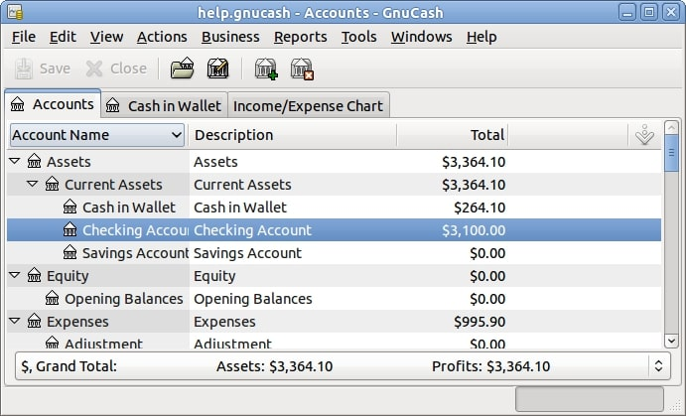
Figure 9 Screen shot of GnuCash Account Summary
While lacking some of the features of a commercial cloud-based product such as Quick-Books, GnuCash offers an affordable (free) secure environment albeit it will take some accounting skill to set-up for project based accounting. This requirement can be met by importing a Chart of Accounts tailored for DCAA requirements.
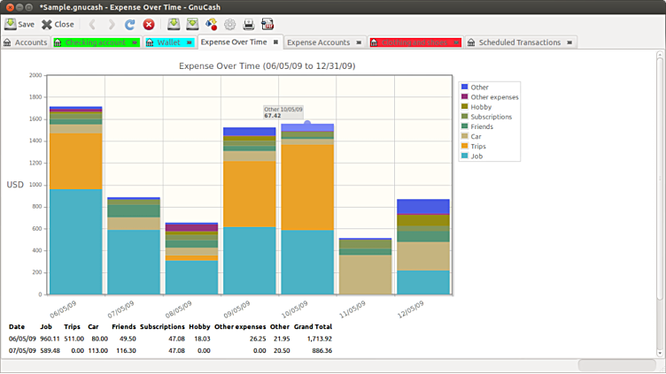
Figure 10 Sample Expense over time report
GnuCash is “adequate” for small businesses needing project-based accounting for supply chain management. Use CSV imports to set up project-specific accounts (e.g., for inventory, materials) and generate custom reports for cost transparency.
- Open Project Community Edition (Free). Linux or Docker versions available of a full featured project management software similar to MS Project. Recommend the free version for most solopreneurs as it easily opens shared project files from clients or prime contractors.

- JumpCloud. JumpCloud (https://jumpcloud.com) is a subscription (SaaS) service that can be very helpful for workgroups in the Level 1 strata i.e., FAR 52.204-21 compliance as it easily addresses and provides a compliant solution for many of the FAR/NIST 800-171 compliance issues at that level for 22 – 27 dollars/month per user. It addresses policy management, patch management, identity management using an agent-based product that is relatively easy to use and set-up – especially with their support team being available. It is a cross-platform solution that pairs well with Windows, Linux or Mac devices. There are other solutions that may be equally effective at a lower cost point such as Synology C2 Identity.

Appendix 2 – Sample Compliance Checklist for Level 1
Level 1 Compliance is greatly simplified when using the recommended tools and software. Here is a copy of the compliance checklist for CMMC Level 1 annotated to show compliance and how met. The first table is contains the 15 requirements from FAR 52.204-21 with the specific CMMC Evaluation Criteria from the assessment guide including guidance on criteria and methodology (i.e., interview, examine, and test) that may be employed during a Level 1 self-assessment. The assessment scope was the CyberLab office/network environment shown in Figure 1 CyberLab Network and Boundaries (Scope).

Table 4 CMMC Level 1 Compliance for CyberLab (Draft)

Family | NIST 800-171 Identifier | Security Requirement | Assessment Objective | Potential Assessment Method and Objects: Examine | How Met by Evaluated Network | Compliant Y/N
Access Control | 3.1.1 | Limit system access to authorized users, processes acting on behalf of authorized users, and devices (including other systems). | Determine If: | [SELECT FROM: Access control policy; procedures addressing account management; security plan; system design documentation; system configuration settings and associated documentation; list of active system accounts and the name of the individual associated with each account; list of conditions for group and role membership; notifications or records of recently transferred, separated, or terminated employees; list of recently disabled system accounts along with the name of the individual associated with each account; access authorization records; account management compliance reviews; system monitoring records; system audit logs and records; other relevant documents or records; list of devices and other systems authorized to connect to organizational systems]. |  | Y
Access Control | 3.1.1[a] |  | authorized users are identified. |  | Identify management via AD, LDAP, authorized user lists, group memberships etc. | Y
Access Control | 3.1.1[b] |  | processes acting on behalf of authorized users are identified. |  | System logs are maintained that identify users and processes | Y
Access Control | 3.1.1[c] |  | devices (including other systems) authorized to connect to the system are identified. |  | Identify management via AD and VPN access | Y
Access Control | 3.1.1[d] |  | system access is limited to authorized users. |  | Identify management via AD, authorized user lists, group memberships etc. | Y
Access Control | 3.1.1[e] |  | system access is limited to processes acting on behalf of authorized users. |  | Group permissions and policies limit system access based on user profile/permissions | Y
Access Control | 3.1.1[f] |  | system access is limited to authorized devices (including other systems). |  | Identify management via AD and/or LDAP | Y
Access Control | 3.1.2 | Limit system access to the types of transactions and functions that authorized users are permitted to execute. | Determine if: | [SELECT FROM: Access control policy; procedures addressing access enforcement; security plan; system design documentation; list of approved authorizations (user privileges) including remote access authorizations; system configuration settings and associated documentation; system audit logs and records; other relevant documents or records].
Access Control | 3.1.2[a] |  | the types of transactions and functions that authorized users are permitted to execute are defined |  | Identity management by user type (admin/user) and user group set by Identity Manager. | y
Access Control | 3.1.2[b] |  | system access is limited to the defined types of transactions and functions for authorized users. |  | Identity management by user type (admin/user) and user group set by Identity Manager. | y
Access Control | 3.1.20 | Verify and control/limit connections to and use of external systems. | Determine if: | [SELECT FROM: Access control policy; procedures addressing the use of external systems; terms and conditions for external systems; security plan; list of types of applications accessible from external systems; system configuration settings and associated documentation; other relevant documents or records]. | Identity management by user type (admin/user) and user group set by Identity Manager. Additional safeguards established by firewall rules for external sites using a mix of geocodes, allow list and block list techniques.. | y
Access Control | 3.1.20[a] |  | connections to external systems are identified. |  | Safeguards established by firewall rules for external sites using a mix of geocodes, allow list and block list techniques.. | Y
Access Control | 3.1.20[b] |  | use of external systems is identified. |  | Access to external sites is logged and monitored by firewall and logging software such as Suricata and Graylog. | Y
Access Control | 3.1.20[c] |  | connections to external systems are verified. |  | Access to external sites is monitored by Suratica which performs real-time scanning for threat signatures and automatically blocks malicious content. | Y
Access Control | 3.1.20[d] |  | use of external systems is verified. |  | Access to external sites is monitored by Suratica which performs real-time scanning for threat signatures and automatically blocks malicious content. | Y
Access Control | 3.1.20[e] |  | connections to external systems are controlled/limited. |  | Access to external sites is monitored by Suratica which performs real-time scanning for threat signatures and automatically blocks malicious content. | Y
Access Control | 3.1.20[f] |  | use of external systems is controlled/limited. |  | Access to external sites is monitored by Suratica which performs real-time scanning for threat signatures and automatically blocks malicious content. | Y
Access Control | 3.1.21 | Limit use of organizational portable storage devices on external systems. | Determine if: | [SELECT FROM: Access control policy; procedures addressing the use of external systems; security plan; system configuration settings and associated documentation; system connection or processing agreements; account management documents; other relevant documents or records].
Access Control | 3.1.21[a] |  | use of organizational portable storage devices containing FCI on external systems is identified and documented. |  | Policy requires any external media to be encrypted and accessed ‘read only’. Transfer of FCI is only permitted via secure file transfer to approved sites. | Y
Access Control | 3.1.21[b] |  | limits on the use of organizational portable storage devices containing FCI on external systems are defined. |  | FCI is not permitted on external systems by policy unless the external system is able to access the information from an approved secure transfer site. | Y
Access Control | 3.1.21[c] |  | use of organizational portable storage devices containing FCI on external systems is limited as defined. |  | FCI is not permitted on external systems by policy unless the external system is able to access the information from an approved secure transfer site. | Y
Identification and Authentication | 3.5.1 | Identify system users, processes acting on behalf of users, and devices. | Determine if: | [SELECT FROM: Identification and authentication policy; procedures addressing user identification and authentication; security plan, system design documentation; system configuration settings and associated documentation; system audit logs and records; list of system accounts; other relevant documents or records]. |  | Y
Identification and Authentication | 3.5.1[a] |  | system users are identified. |  | All system users are enrolled according to policy into a user database (AD) that defines user name, group membership, and permissions. | Y
Identification and Authentication | 3.5.1[b] |  | processes acting on behalf of users are identified. |  | System logs are maintained that identify users and processes | Y
Identification and Authentication | 3.5.1[c] |  | devices accessing the system are identified. |  | Access to the system is monitored by Suratica which logs access, performs real-time scanning for threat signatures and automatically blocks malicious content. | Y
Identification and Authentication | 3.5.2 | Authenticate (or verify) the identities of users, processes, or devices, as a prerequisite to allowing access to organizational systems | Determine if: | [SELECT FROM: Identification and authentication policy; procedures addressing authenticator management; security plan; system design documentation; system configuration settings and associated documentation; list of system authenticator types; change control records associated with managing system authenticators; system audit logs and records; other relevant documents or records]. |  | Y
Identification and Authentication | 3.5.2[a] |  | the identity of each user is authenticated or verified as a prerequisite to system access. |  | User access is managed by the Identity Management process controlled by AD | Y
Identification and Authentication | 3.5.2[b] |  | the identity of each process acting on behalf of a user is authenticated or verified as a prerequisite to system access. |  | User permissions are verified at the time of log-in and again at the time of access to system resources. The transactions are logged in various user logs. | Y
Identification and Authentication | 3.5.2[c] |  | the identity of each device accessing or connecting to the system is authenticated or verified as a prerequisite to system access. |  | Device access is controlled via a combination of user identity and multi-factor authentication/ | Y
Media Protection | 3.8.3 | Sanitize or destroy system media containing FCI before disposal or release for reuse. | Determine if: | [SELECT FROM: System media protection policy; procedures addressing media sanitization and disposal; applicable standards and policies addressing media sanitization; security plan; media sanitization records; system audit logs and records; system design documentation; system configuration settings and associated documentation; other relevant documents or records]. |  | Y
Media Protection | 3.8.3[a] |  | system media containing FCI is sanitized or destroyed before disposal. |  | Policy and procedures call for the destruction of media rendering it unusable. | Y
Media Protection | 3.8.3[b] |  | system media containing FCI is sanitized before it is released for reuse. |  | Reuse of media that previously was used for FCI is not permitted by company policy. | Y
Personnel Security | 3.10.1 | Limit physical access to organizational systems, equipment, and the respective operating environments to authorized individuals. | Determine if: | [SELECT FROM: Physical and environmental protection policy; procedures addressing physical access authorizations; security plan; authorized personnel access list; authorization credentials; physical access list reviews; physical access termination records and associated documentation; other relevant documents or records]. |  | Y
Personnel Security | 3.10.1[a] |  | authorized individuals allowed physical access are identified. |  | All authorized users are identified in the AD user database. | Y
Personnel Security | 3.10.1[b] |  | physical access to organizational systems is limited to authorized individuals. |  | Physical security policy and procedures are used to limit opportunity to physically access a device. Complex passwords and multifactor authentication are used to control logical access. | Y
Personnel Security | 3.10.1[c] |  | physical access to equipment is limited to authorized individuals. |  | Physical security policy and procedures are used to limit opportunity to physically access a device. | Y
Physical Protection | 3.10.1[d] |  | physical access to operating environments is limited to authorized individuals. |  | Physical security policy and visitor control procedures are used to limit opportunity to physically access a device. | Y
Physical Protection | 3.10.3 | Escort visitors and monitor visitor activity. | Determine if: | [SELECT FROM: Physical and environmental protection policy; procedures addressing physical access control; security plan; physical access control logs or records; inventory records of physical access control devices; system entry and exit points; records of key and lock combination changes; storage locations for physical access control devices; physical access control devices; list of security safeguards controlling access to designated publicly accessible areas within facility; other relevant documents or records]. |  | Y
Physical Protection | 3.10.3[a] |  | visitors are escorted. |  | Visitor control policy requires all visitors to log in, show identification, be badged as a visitor, and be escorted while in the facility. | Y
Physical Protection | 3.10.3[b] |  | visitor activity is monitored. |  | Visitor escorts monitor visitor activities. Visitors are not left alone inside controlled areas. | y
Physical Protection | 3.10.4 | Maintain audit logs of physical access. | Determine if audit logs of physical access are maintained. | [SELECT FROM: Physical and environmental protection policy; procedures addressing physical access control; security plan; physical access control logs or records; inventory records of physical access control devices; system entry and exit points; records of key and lock combination changes; storage locations for physical access control devices; physical access control devices; list of security safeguards controlling access to designated publicly accessible areas within facility; other relevant documents or records]. |  | Y
Physical Protection | 3.10.5 | Control and manage physical access devices. | Determine if: | [SELECT FROM: Physical and environmental protection policy; procedures addressing physical access control; security plan; physical access control logs or records; inventory records of physical access control devices; system entry and exit points; records of key and lock combination changes; storage locations for physical access control devices; physical access control devices; list of security safeguards controlling access to designated publicly accessible areas within facility; other relevant documents or records]. |  | Y
Physical Protection | 3.10.5[a] |  | physical access devices are identified. |  | Physical access controls consist of locked doors and file cabinets and keys are numbered and controlled. | Y
Physical Protection | 3.10.5[b] |  | physical access devices are controlled. |  | Physical access controls consist of locked doors and file cabinets and keys are numbered and controlled. | Y
Physical Protection | 3.10.5[c] |  | physical access devices are managed. |  | Physical access controls consist of locked doors and file cabinets and keys are numbered and controlled. | Y
System and Communications Protection | 3.13.1 | Monitor, control, and protect communications (i.e., information transmitted or received by organizational systems) at the external boundaries and key internal boundaries of organizational systems. | Determine if: | [SELECT FROM: System and communications protection policy; procedures addressing boundary protection; security plan; list of key internal boundaries of the system; system design documentation; boundary protection hardware and software; enterprise security architecture documentation; system audit logs and records; system configuration settings and associated documentation; other relevant documents or records]. |  | Y
System and Communications Protection | 3.13.1[a] |  | the external system boundary is defined. |  | See Attachment 1 – Network Diagram | y
System and Communications Protection | 3.13.1[b] |  | key internal system boundaries are defined. |  | See Attachment 1 – Network Diagram | Y
System and Communications Protection | 3.13.1[c] |  | communications are monitored at the external system boundary. |  | The NetGate 2100 firewall appliance an pfSense software provide perimeter control of network traffic. These tools are augmented by Suratica IDS/IPS | Y
System and Communications Protection | 3.13.1[d] |  | communications are monitored at key internal boundaries. |  | Internal network traffic is monitored at the device level by BitDefender Gravity Zone end point management and firewall software. | Y
System and Communications Protection | 3.13.1[e] |  | communications are controlled at the external system boundary. |  | Network traffic is controlled by firewall rules and allowed/blocked sites | Y
System and Communications Protection | 3.13.1[f] |  | communications are controlled at key internal boundaries. |  | Internal network traffic is controlled by firewall rules and antimalware software. | Y
System and Communications Protection | 3.13.1[g] |  | communications are protected at the external system boundary. |  | The NetGate 2100 firewall appliance an pfSense software provide perimeter control of network traffic. These tools are augmented by Suratica IDS/IPS | Y
System and Communications Protection | 3.13.1[h] |  | communications are protected at key internal boundaries. |  | Internal network traffic is monitored at the device level by BitDefender Gravity Zone end point management and firewall software. | y
ySystem and Communications Protection | 3.13.5 | Implement subnetworks for publicly accessible system components that are physically or logically separated from internal networks. | Determine if: | [SELECT FROM: System and communications protection policy; procedures addressing boundary protection; security plan; list of key internal boundaries of the system; system design documentation; boundary protection hardware and software; system configuration settings and associated documentation; enterprise security architecture documentation; system audit logs and records; other relevant documents or records].
System and Communications Protection | 3.13.5[a] |  | publicly accessible system components are identified. |  | N/A No publicly accessible components or subsystems are included in the network. | Y
System and Communications Protection | 3.13.5[b] |  | subnetworks for publicly accessible system components are physically or logically separated from internal networks. |  | N/A | Y
System and Information Integrity | 3.14.1 | Identify, report, and correct system flaws in a timely manner. | Determine if: | [SELECT FROM: System and information integrity policy; procedures addressing flaw remediation; procedures addressing configuration management; security plan; list of flaws and vulnerabilities potentially affecting the system; list of recent security flaw remediation actions performed on the system (e.g., list of installed patches, service packs, hot fixes, and other software updates to correct system flaws); test results from the installation of software and firmware updates to correct system flaws; installation/change control records for security-relevant software and firmware updates; other relevant documents or records]. |  | Y
System and Information Integrity | 3.14.1[a] |  | the time within which to identify system flaws is specified. |  | System errors are required to be reported immediately by system policy. | Y
System and Information Integrity | 3.14.1[b] |  | system flaws are identified within the specified time frame. |  | System errors are required to be reported immediately by system policy. | Y
System and Information Integrity | 3.14.1[c] |  | the time within which to report system flaws is specified. |  | System errors are required to be reported immediately by system policy. | Y
System and Information Integrity | 3.14.1[d] |  | system flaws are reported within the specified time frame. |  | System errors are required to be reported immediately by system policy. | Y
System and Information Integrity | 3.14.1[e] |  | the time within which to correct system flaws is specified. |  | Policy requires system errors or defects to be remediated within 24 hours using local assets or elevated for resolution if not correctable within that timeframe. | Y
System and Information Integrity | 3.14.1[f] |  | system flaws are corrected within the specified time frame. |  | Policy requires system errors or defects to be remediated within 24 hours using local assets or elevated for resolution if not correctable within that timeframe. | Y
System and Information Integrity | 3.14.2 | Provide protection from malicious code at designated locations within organizational systems. | Determine if: | [SELECT FROM: System and information integrity policy; configuration management policy and procedures; procedures addressing malicious code protection; records of malicious code protection updates; malicious code protection mechanisms; security plan; system design documentation; system configuration settings and associated documentation; record of actions initiated by malicious code protection mechanisms in response to malicious code detection; scan results from malicious code protection mechanisms; system audit logs and records; other relevant documents or records]. |  | Y
System and Information Integrity | 3.14.2[a] |  | designated locations for malicious code protection are identified. |  | Protection from malicious code are provided at the network boundary by Syratica software and the source is blocked. Additionally, end point protection is provided on each network device using Bitdefender Gravity Zone. | Y
System and Information Integrity | 3.14.2[b] |  | protection from malicious code at designated locations is provided. |  | Protection from malicious code are provided at the network boundary by Syratica software and the source is blocked. Additionally, end point protection is provided on each network device using Bitdefender Gravity Zone. | Y
System and Information Integrity | 3.14.4 | Update malicious code protection mechanisms when new releases are available. | Determine if malicious code protection mechanisms are updated when new releases are available. | [SELECT FROM: System and information integrity policy; configuration management policy and procedures; procedures addressing malicious code protection; malicious code protection mechanisms; records of malicious code protection updates; security plan; system design documentation; system configuration settings and associated documentation; scan results from malicious code protection mechanisms; record of actions initiated by malicious code protection mechanisms in response to malicious code detection; system audit logs and records; other relevant documents or records]. |  | Y
System and Information Integrity | 3.14.5 | Perform periodic scans of organizational systems and real-time scans of files from external sources as files are downloaded, opened, or executed. | Determine if: | [SELECT FROM: System and information integrity policy; configuration management policy and procedures; procedures addressing malicious code protection; malicious code protection mechanisms; records of malicious code protection updates; security plan; system design documentation; system configuration settings and associated documentation; scan results from malicious code protection mechanisms; record of actions initiated by malicious code protection mechanisms in response to malicious code detection; system audit logs and records; other relevant documents or records]. |  | Y
System and Information Integrity | 3.14.5[a] |  | the frequency for malicious code scans is defined. |  | Policy requires scan setting for on-access scanning and daily system scans. | Y
System and Information Integrity | 3.14.5[b] |  | malicious code scans are performed with the defined frequency. |  | Policy requires scan setting for on-access scanning and daily system scans. Scan logs are maintained and the Bitdefender Dashboard will identify overdue scans. | Y
System and Information Integrity | 3.14.5[c] |  | real-time malicious code scans of files from external sources as files are downloaded, opened, or executed are performed. |  | Real-time scanning is performed at the network boundary by Suratica ant at each endpoint by Bitdefender. | Y

Table 5 How CH Recommended Software Stack meets FAR 52-204-21 and NIST 800-171 Level 1 Requirements
FAR 52.204-21 Requirement | Description | Enterprise Alignment | Coverage
1. Limit information system access to authorized users, processes acting on behalf of authorized users, or devices (including other information systems). | Restrict access to systems handling FCI to only authorized entities. | JumpCloud provides robust IAM with SSO, MFA, and conditional access policies to enforce user and device authorization. It supports role-based access control (RBAC) and integrates with various systems to limit access. | Full
2. Limit information system access to the types of transactions and functions that authorized users are permitted to execute. | Ensure users can only perform authorized actions within the system. | JumpCloud’s RBAC and conditional access policies allow granular control over user permissions, restricting actions based on roles and policies. | Full
3. Verify and control/limit connections to and use of external information systems. | Control connections to external systems to prevent unauthorized access. | JumpCloud’s device management and conditional access can restrict connections based on device compliance and network policies, though specific external system controls may depend on integrations. | Partial (Assumes integration with network security tools; may require additional configuration.) Compliance would be improved with commercial grade firewall like NetGear 2100
4. Control information posted or processed on publicly accessible information systems. | Prevent unauthorized posting or processing of FCI on public systems. | JumpCloud’s focus is on internal system access, not public systems. Compliance depends on customer policies to avoid public posting, which JumpCloud does not directly manage. | None (Customer responsibility to enforce through policies and procedures.)
5. Identify information system users, processes acting on behalf of users, or devices. | Ensure all users and devices accessing the system are identified. | JumpCloud’s IAM and device management capabilities provide user and device identification through unique credentials and device profiles. | Full
6. Authenticate (or verify) the identities of those users, processes, or devices, as a prerequisite to allowing access to organizational information systems. | Require authentication (e.g., passwords, MFA) for access. | JumpCloud’s MFA and SSO features enforce strong authentication for users and devices, supporting compliance with this requirement. | Full
7. Sanitize or destroy information system media containing Federal Contract Information before disposal or release for reuse. | Ensure FCI is securely removed from media before disposal or reuse. | JumpCloud does not directly manage physical media sanitization, as it is a cloud-based platform. This is a customer responsibility. | None (Physical media management outside JumpCloud’s scope.)
8. Limit physical access to organizational information systems, equipment, and the respective operating environments to authorized individuals. | Restrict physical access to systems hosting FCI. | JumpCloud operates in the cloud, so physical access controls are managed by the cloud provider (e.g., AWS). Customers must ensure their own physical security for endpoints. | None (Customer responsibility for on-premises equipment.)
9. Escort visitors and monitor visitor activity; maintain audit logs of physical access; and control and manage physical access devices. | Manage and monitor physical access to facilities. | JumpCloud does not handle physical access controls or visitor management, as it focuses on digital access. | None (Physical security outside JumpCloud’s scope.)
10. Monitor, control, and protect organizational communications (i.e., information transmitted or received by organizational information systems) at the external boundaries and key internal boundaries of the information systems. | Protect communications at system boundaries. | JumpCloud’s conditional access and device compliance features can help secure communications, but full boundary protection may require integration with firewalls or network security tools. | Partial (Requires additional network security solutions.) Compliance would be improved with commercial grade firewall like NetGear 2100
11. Implement subnetworks for publicly accessible system components that are physically or logically separated from internal networks. | Isolate public-facing systems from internal networks. | JumpCloud does not directly manage network architecture or subnetworks, which is a customer responsibility. | None (Network design outside JumpCloud’s scope.)  May be NA depending on network i.e., no publicly accessible systems.
12. Identify, report, and correct information and information system flaws in a timely manner. | Address system vulnerabilities promptly. | JumpCloud’s device management can detect non-compliant devices and enforce updates, but full vulnerability management requires integration with other tools. | Partial (Supports device compliance but not comprehensive vulnerability management such as provided by Ubuntu Pro or Senteon)
13. Provide protection from malicious code at appropriate locations within organizational information systems. | Deploy anti-malware solutions. | JumpCloud integrates with endpoint security solutions (e.g., EDR tools) to enforce anti-malware policies but does not provide anti-malware directly. | Partial (Requires integration with anti-malware tools such as the included BitDefender to reach full compliance)
14. Update malicious code protection mechanisms when new releases are available. | Keep anti-malware solutions up to date. | JumpCloud can enforce device compliance policies to ensure updated software, but updating anti-malware tools depends on third-party integrations. | Partial (Supports enforcement but relies on external tools such as the included BitDefender to reach full compliance )
15. Perform periodic scans of the information system and real-time scans of files from external sources as files are downloaded, opened, or executed. | Conduct regular and real-time system scans for malicious code. | JumpCloud does not provide scanning capabilities, which are typically handled by endpoint security solutions. | None (Requires separate security tools such as the included BitDefender to reach Full compliance)

Appendix 3 - Windows 11 or Linux?
For years Microsoft’s Windows has been the dominant desktop software in both home use and office environments. Microsoft Windows (combined Windows 10 and Windows 11) holds a dominant position with approximately 70.62% of the global desktop OS market as of February 2025. Windows 10 remains the most popular version, but Windows 11 is gaining traction, rising from 26.52% in December 2023 to 31% by July 2024, driven by the impending end of Windows 10 support in October 2025.

Table 6 Market Share of Desktop Operating Systems
Operating System | Market Share (%)
Windows 10 | 65.0%
Windows 11 | 31.0%
macOS | 15.74%
Linux | 3.81%
Others* | 2.42%
Note: "Others" includes ChromeOS (1.92% as of January 2025) and other minor operating systems like FreeBSD, which have negligible shares (e.g., FreeBSD at 0% in some reports).
A key reason for installing Linux is its built-in security advantage over Windows. Windows uses a discretionary access control (DAC) model, where users or administrators define permissions. It relies heavily on the Security Account Manager (SAM) and Active Directory for enterprise environments. In stand-alone environments (such as the Solopreneur) Windows has been criticized for its less secure default settings (e.g., permissive user privileges), although Windows 10 and 11 have improved with features like Secure Boot and Credential Guard albeit with increased hardware requirements. However, telemetry and default-enabled features can raise privacy concerns with user data being seditiously acquired and used for commercial purposes.
Another concern is there is substantial data and evidence indicating that employees using work computers for personal activities—such as web browsing, gaming, and social media—can lead to security compromises. These activities increase the risk of malware infections, phishing attacks, data leaks, and other cyber threats, often due to human error, unsecured networks, or exposure to malicious content. Key evidence includes Proofpoint’s finding that 35% of U.S. employees use work devices for personal tasks, Keep Aware’s report on 70% of malware targeting browsers, and Kaspersky’s case of ransomware spread via personal use. Having a Linux based work computer may serve as a disincentive for employees using the same computer for work and personal (i.e., recreational) tasks. While Linux has a security advantage both Linux and Windows require strong policies and enforcement to prevent data breaches and potential malware intrusion.
Herer are some thoughts as to why Linux is growing as a desktop operating system, reaching a market share of approximately 3.81% by February 2025 (up from 3.12% in July 2023, per StatCounter).

Dissatisfaction with Windows
End of Windows 10 Support: Microsoft’s announcement that Windows 10 support will end in October 2025 has pushed some users to explore alternatives. Windows 11’s stricter hardware requirements (e.g., TPM 2.0, newer CPUs) exclude older PCs, frustrating users who cannot or do not want to upgrade. Also, Windows 11’s increased telemetry, integration of AI features (e.g., Copilot), and intrusive updates have raised privacy concerns among tech-savvy users. Linux distributions (distros) like Ubuntu, Fedora, or Linux Mint offer greater control over data and system behavior, appealing to users prioritizing customization and privacy.

Improved User Experience
User-Friendly Distros: Modern Linux distributions such as Ubuntu and Linux Mint have polished desktop environments (e.g., GNOME, KDE Plasma) that rival Windows and macOS in usability. These distros offer intuitive interfaces, pre-installed software, and robust community support, lowering the entry barrier for non-technical users.

Developer and Professional Adoption
Linux remains the preferred OS for developers due to its robust terminal, containerization tools (e.g., Docker, Kubernetes), and compatibility with cloud infrastructure. The rise of remote work and DevOps has driven adoption among professionals. Additionally, Linux’s open-source nature eliminates licensing costs, making it appealing for businesses, startups, and individuals.

Challenges and Limitations
Learning Curve: Despite improvements, Linux can still intimidate new users due to its reliance on terminal commands for some tasks and fragmented distro ecosystem.
Software Compatibility: While Proton and Wine (which allow installing some windows apps on Linux) have improved compatibility, some proprietary software (e.g., Adobe Suite, certain enterprise tools) remains Windows- or macOS-exclusive, limiting Linux’s appeal for specific professionals. This concern is abated however in the wide availability of open-source alternatives. Additionally, security issues inherent with Windows can become an issue on Linux if such tools are used. The preferred solution if a Windows app is absolutely necessary is to install it in a containerized environment such as Docker or Kubernetes to isolate security issues from the host system.

Key Linux (Ubuntu Pro) Security Features vs. Windows 11
The following documents the inherent security features that are available in Ubuntu Pro (Pro), a subscription-based service from Canonical (free for up to five (5) users and $25 per year per workstation for desktop environments in excess of 5). Canonical offers discounted pricing for approved institutions (e.g., schools, research, academia). Investigation of these discounts by NAPEX is recommended.
Pro enhances the security of Ubuntu systems by providing extended security maintenance, FIPS-validated cryptographic modules, and compliance automation tools. Its disk partitioning and full disk encryption (FDE) features are critical for protecting data at rest, aligning with NIST Cybersecurity Framework (CSF) and NIST 800-53/800-171 requirements, particularly for organizations handling sensitive data, such as government contractors.
While Widows 11
Long-lerm security. The 10-year Expanded Security Maintenance and Livepatch included in the paid version reduce vulnerabilities over a longer period without downtime, critical for NIST’s PR.MA-1 and CIS Control 3.
FIPS, Common Criteria, and CIS/DISA-STIG certifications make Ubuntu Pro ideal for regulated industries, surpassing Windows 11’s compliance scope for open-source environments. Pro’s open-source model, strict privilege controls, and minimal telemetry align better with NIST’s PR.DS-2 and CIS Control 8 (Malware Defenses).
Pro is free for up to 5 machines (50 for Ubuntu community members), with discounted pricing for education and research, making it accessible for small organizations.

Disk Partitioning and Full Disk Encryption in Ubuntu Pro
Ubuntu Pro enhances the security of Ubuntu systems by providing extended security maintenance, FIPS-validated cryptographic modules, and compliance automation tools. Its disk partitioning and full disk encryption (FDE) features are critical for protecting data at rest, aligning with NIST Cybersecurity Framework (CSF) and NIST 800-53/800-171 requirements, particularly for organizations handling sensitive data. Disk Partitioning in Ubuntu ProUbuntu Pro does not directly modify Ubuntu’s default disk partitioning capabilities but supports advanced configurations through the Ubuntu installer and tools like the Ubuntu Security Guide (USG). Partitioning is typically set up during installation, with options that enhance security and compliance.

Default Partitioning Options:
Automatic Partitioning: The Ubuntu installer (e.g., for Ubuntu 22.04, 24.04) offers an “Erase disk and install Ubuntu” option, which creates a default partition layout including:EFI System Partition (ESP): 100–550 MB, formatted as FAT32, mounted at /boot/efi for UEFI systems.
- Boot Partition: ~500 MB, formatted as ext4, mounted at /boot. Required for unencrypted boot loader support.
- Root Partition: Remaining space, formatted as ext4, mounted at /, often using Logical Volume Management (LVM) for flexibility.
- Swap Area: Size based on RAM (e.g., 2–4 GB), used for memory paging. Recent Ubuntu versions may use a swap file instead of a partition, which can be encrypted.
Manual Partitioning: The “Something else” option allows custom setups, such as separate partitions for /home, /tmp, /var, /var/log, and /var/log/audit, as recommended by NIST 800-171 for enhanced security.
LVM Support: LVM is enabled by default in automatic partitioning or can be configured manually, allowing dynamic resizing of partitions post-installation, which supports NIST 800-53’s CM-8 (System Component Inventory) by facilitating scalable storage management.

NIST-Relevant Partitioning Features
Segregation of Data: Separate partitions for /var/log and /var/log/audit ensure audit logs are isolated, aligning with NIST 800-53 AU-2 (Audit Events) and CIS Control 4 (Continuous Monitoring). This reduces the risk of log tampering during personal use (e.g., 35% of employees use work devices for personal tasks, Proofpoint 2018).
Custom Partition Sizes: NIST 800-171 suggests specific partitions (e.g., /tmp, /home) to limit data exposure. Ubuntu Pro’s manual partitioning supports these, though users must follow CIS benchmarks (e.g., RHEL8 CIS guide recommends 1–2 GB for /tmp) for compliance.
Scalability: LVM allows resizing logical volumes without downtime, supporting NIST 800-53 MA-2 (Controlled Maintenance) by enabling flexible storage management for time accounting or GnuCash data.
Full Disk Encryption (FDE) in Ubuntu Pro enhances FDE through LUKS (Linux Unified Key Setup) and optional TPM (Trusted Platform Module) integration, providing robust data protection at rest. These features are critical for NIST compliance, particularly in regulated environments.
FDE Implementation: LUKS Encryption: Ubuntu’s installer supports FDE using LUKS, encrypting all partitions except /boot and the ESP. LUKS uses AES (Advanced Encryption Standard) with a user-supplied passphrase or recovery key to secure data.
Default Algorithm: LUKS uses Argon2i for password hashing, which is more secure against brute-force attacks but not yet FIPS 140-3 certified. Ubuntu Pro allows switching to PBKDF2 for FIPS compliance.
TPM-Backed FDE: Available as an experimental feature in Ubuntu 23.10 and later, TPM-backed FDE seals encryption keys to the TPM, eliminating passphrase prompts at boot and protecting against “evil maid” attacks (where boot software is tampered with). This requires UEFI and a TPM 2.0 chip.

FIPS 140-3 Compliance
Ubuntu Pro provides FIPS 140-2/3 certified cryptographic modules (e.g., OpenSSL, libgcrypt, GnuTLS), validated by NIST-approved labs. These modules ensure LUKS encryption complies with FIPS standards when using PBKDF2. FIPS options include:
- fips-updates: Includes security patches, recommended for compliance.
- fips-preview: Modules awaiting NIST certification, suitable for FedRAMP interim requirements.
- fips: Exact NIST-certified binaries, but may contain vulnerabilities due to lack of updates.
Canonical’s continuous patching (up to 12 years with Ubuntu Pro) addresses vulnerabilities in FIPS modules, aligning with NIST 800-53 SI-2 (Flaw Remediation).

TPM and Secure Boot
TPM-backed FDE ties encryption keys to UEFI Secure Boot measurements, ensuring only trusted boot software (e.g., GRUB, kernel) can access data. This enhances protection against bootkits and unauthorized access, aligning with NIST 800-53 SC-12 (Cryptographic Key Management).
Secure Boot verifies the integrity of boot components, supporting NIST 800-53 SI-7 (Software, Firmware, and Information Integrity).

Support for NIST Requirements
Ubuntu Pro’s partitioning and FDE features directly support NIST 800-53 and 800-171 controls. Below is a detailed mapping:

NIST 800-53 Controls:
SC-28 (Protection of Information at Rest):
FDE: LUKS encrypts all partitions (except /boot and ESP), protecting time accounting data (e.g., GnuCash project accounts) from unauthorized access if a device is stolen. TPM-backed FDE enhances this by securing keys, reducing risks from physical attacks.
Ubuntu Pro Advantage: FIPS 140-3 certified modules ensure cryptographic compliance, critical for DCAA-related data.
AU-2 (Audit Events) and AU-9 (Protection of Audit Information):
Partitioning: Separate /var/log and /var/log/audit partitions isolate audit logs, preventing tampering and supporting audit trails for time accounting software (e.g., tracking GnuCash transactions).
Ubuntu Pro Advantage: USG automates hardening to CIS and DISA-STIG benchmarks, ensuring log integrity and compliance with audit requirements.
CM-8 (System Component Inventory):Partitioning:
LVM allows dynamic management of partitions, facilitating inventory tracking of storage components.
Ubuntu Pro Advantage: Landscape integration provides centralized monitoring, supporting asset management for compliance.
SC-12 (Cryptographic Key Management):
FDE: TPM-backed FDE securely stores encryption keys, reducing manual key management risks.
Ubuntu Pro Advantage: FIPS-validated modules ensure cryptographic operations meet NIST standards, critical for DCAA-compliant systems.

NIST 800-171 Requirements:
3.5.10 (Cryptographic Protection):
Ubuntu Pro’s FIPS 140-3 modules and LUKS encryption meet this requirement by securing data at rest, essential for protecting time accounting records (e.g., GnuCash data for DCAA audits).
3.1.5 (Least Privilege):
Partitioning isolates sensitive data (e.g., /home for user data, /var/log/audit for logs), limiting access to authorized users. Snap confinement for GnuCash further restricts access, aligning with this control.
3.13.11 (Cryptographic Protection for Data at Rest):
FDE ensures all data, including time accounting records, is encrypted, preventing unauthorized access if devices are compromised during personal use (e.g., 35% of employees use work devices for personal tasks, Proofpoint 2018).
3.3.1 (Audit and Accountability):
Separate audit partitions and USG’s automated hardening ensure robust logging, supporting DCAA’s audit trail requirements for time tracking.

Appendix 4 - DCAA Chart of Accounts for GnuCash

Below, is a sample DCAA-compliant chart of accounts tailored for GnuCash, designed to meet the requirements of the Defense Contract Audit Agency (DCAA) for project-based accounting.
The chart supports segregation of direct, indirect, and unallowable costs, as well as project-specific tracking for inventory and materials, aligning with DCAA’s standards (e.g., FAR 31.201-6, SF 1408) and SCMA’s needs for supply chain cost transparency.
- Project-Based Tracking
- Accounts for specific projects or contracts (e.g., Project A, Project B).
- GAAP Compliance: Double-entry accounting for audit readiness.
- Inventory and Materials: Accounts for tracking raw materials and cost of goods sold (COGS).

CSV Content
Below is the sample chart in CSV format, suitable for GnuCash’s CSV import feature (File > Import > Import Accounts from CSV). The columns include Account Name, Account Type, Parent Account, Account Code, and Description, as required for GnuCash import.csv
============================== Chart of Accounts =====================
Account Name,Account Type,Parent Account,Account Code,Description
Assets,Asset,,1000,Parent account for all assets
Assets:Current Assets,Asset,Assets,1100,Current assets for operations
Assets:Current Assets:Cash,Asset,Assets:Current Assets,1110,Operating cash account
Assets:Current Assets:Accounts Receivable,Asset,Assets:Current Assets,1120,Receivables from contracts
Assets:Current Assets:Inventory:Project A,Asset,Assets:Current Assets,1131,Raw materials for Project A
Assets:Current Assets:Inventory:Project B,Asset,Assets:Current Assets,1132,Raw materials for Project B
Liabilities,Liability,,2000,Parent account for all liabilities
Liabilities:Accounts Payable,Liability,Liabilities,2100,Payables to vendors
Liabilities:Accrued Payroll,Liability,Liabilities,2200,Accrued employee wages
Equity,Equity,,3000,Parent account for equity
Equity:Retained Earnings,Equity,Equity,3100,Accumulated earnings
Income,Income,,4000,Parent account for revenue
Income:Project A:Revenue,Income,Income,4101,Revenue from Project A
Income:Project B:Revenue,Income,Income,4102,Revenue from Project B
Expenses,Expense,,5000,Parent account for expenses
Expenses:Direct Costs:Project A,Expense,Expenses,5101,Direct costs for Project A
Expenses:Direct Costs:Project A:Labor,Expense,Expenses:Direct Costs:Project A,5111,Direct labor for Project A
Expenses:Direct Costs:Project A:Materials,Expense,Expenses:Direct Costs:Project A,5112,Direct materials for Project A
Expenses:Direct Costs:Project A:COGS,Expense,Expenses:Direct Costs:Project A,5113,Cost of goods sold for Project A
Expenses:Direct Costs:Project B,Expense,Expenses,5102,Direct costs for Project B
Expenses:Direct Costs:Project B:Labor,Expense,Expenses:Direct Costs:Project B,5121,Direct labor for Project B
Expenses:Direct Costs:Project B:Materials,Expense,Expenses:Direct Costs:Project B,5122,Direct materials for Project B
Expenses:Direct Costs:Project B:COGS,Expense,Expenses:Direct Costs:Project B,5123,Cost of goods sold for Project B
Expenses:Indirect Costs,Expense,Expenses,5200,Indirect costs pool
Expenses:Indirect Costs:Overhead,Expense,Expenses:Indirect Costs,5210,Overhead costs (e.g., facilities, utilities)
Expenses:Indirect Costs:Overhead:Labor,Expense,Expenses:Indirect Costs:Overhead,5211,Indirect labor for overhead
Expenses:Indirect Costs:G&A,Expense,Expenses:Indirect Costs,5220,General and administrative costs
Expenses:Indirect Costs:G&A:Rent,Expense,Expenses:Indirect Costs:G&A,5221,G&A rent expenses
Expenses:Unallowable Costs,Expense,Expenses,5300,Unallowable costs per FAR 31.201-6
Expenses:Unallowable Costs:Entertainment,Expense,Expenses:Unallowable Costs,5310,Unallowable entertainment expenses
Expenses:Unallowable Costs:Alcohol,Expense,Expenses:Unallowable Costs,5311,Unallowable alcohol expenses
======================= End Chart of Acccounts
Explanation of StructureAccount Hierarchy: Organized to segregate direct costs (e.g., “Project A:Labor,” “Project A:Materials”), indirect costs (e.g., “Overhead,” “G&A”), and unallowable costs (e.g., “Entertainment”), per DCAA’s FAR 31.201-6.
Project-Based: Separate sub-accounts for “Project A” and “Project B” (replace with actual contract names/CLINs) to track direct costs, supporting SCMA’s project-based accounting and DCAA’s job costing requirements (SF 1408).
Inventory and Materials: Includes accounts like “Assets:Current Assets:Inventory:Project A” and “Expenses:Direct Costs:Project A:COGS” for tracking inventory and materials costs, as discussed in your prior question.
Audit Readiness: Account codes (e.g., 5111, 5221) and descriptions facilitate audit trails, though manual reporting is needed for DCAA compliance.
GAAP Compliance: Double-entry structure ensures GAAP adherence, critical for both SCMA and DCAA.

Pamphlet Controlled Unclassified Information: Frequently Asked Questions
Ubuntu Pro installations provide full-disk encryption meeting FIPS 140 requirements and use TPM for data transfers.
CMMC Assessment Guide Level 1 Version – 2.13 | September 2024 DoD-CIO-00002 (ZRIN 0790-ZA18)
Portions of this article were researched and written using Grok 3 AI and then edited and reformatted.
This article was largely written by Grok 3 AI

